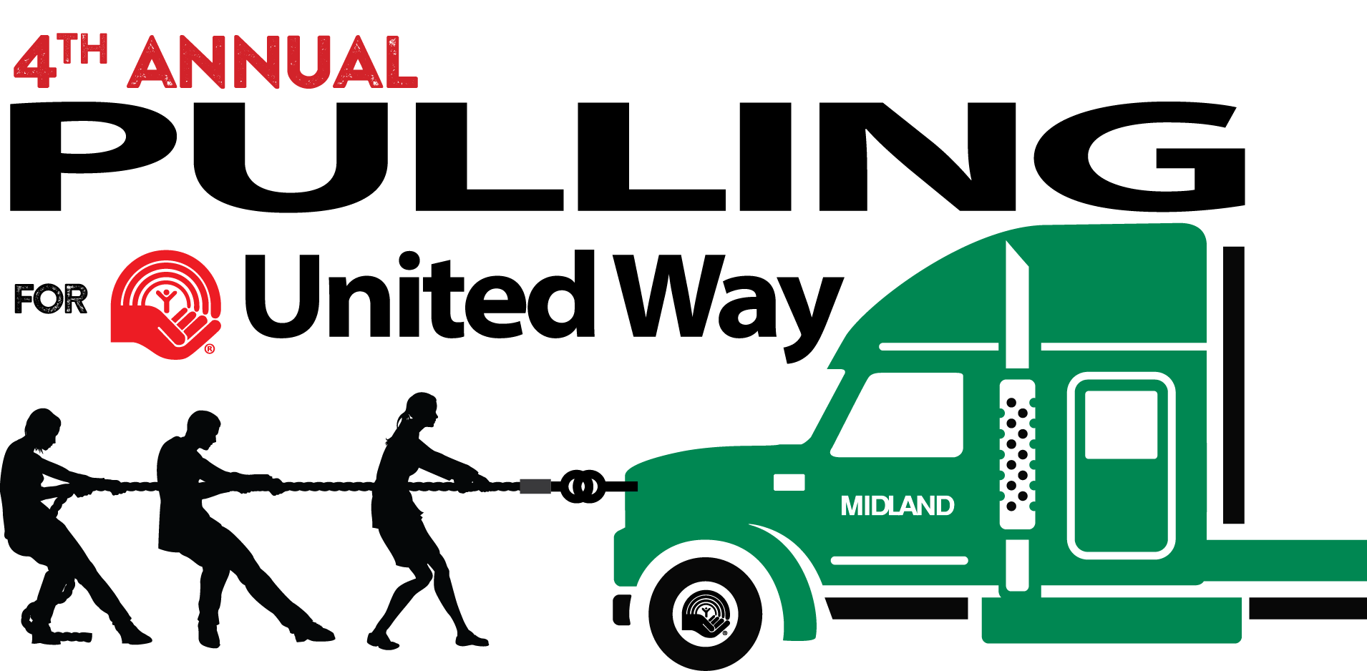
2018 EVENT REGISTRATION FORM
September 15, 2018

Registration Information
Team Name: ______________________________________________________________________________
Company (if applicable): ____________________________________________________________________
Address: _________________________________________________________________________________
City: ____________________________________ Province: ____________ Postal Code: _______________

Team Information
Team Captain: _______________________________________________________
Email: ______________________________________________________________
Contact Phone #: _____________________________________________________
Team Members: (Two alternate team members are allowed, but not required)
1. ___________________________________________ 7. _______________________________________
2. ___________________________________________ 8. _______________________________________
3. ___________________________________________ 9. _______________________________________
4. ___________________________________________ 10. _______________________________________
5. ___________________________________________ Alternate 1: ________________________________
6. ___________________________________________ Alternate 2: ________________________________
Teams must include 12 people, with a minimum of two women. Team members must be 19 years of age or older.
All participants will be required to sign a waiver before participating in the competition.

Registration Payment - $1,000

Payment enclosed:
Payment form: Cheque (payable to Midland Transport) Visa Mastercard
Card Number: ___________________________________________________________________________
Expiry Date: _____________________________________________________ CVV: __________________
Name on Card: ___________________________________________________________________________
Cardholder’s Signature: ____________________________________________________________________
- The event is open to the first 16 teams to register. Registration form must be submitted by:
Wednesday, August 15, 2018 to: Pulling for United Way
100 Midland Drive
Dieppe, NB, E1A 6X4

- You can also email your registration form to: pullingforuw@midlandtransport.com

- Registration fee must be received before Wednesday, August 15, 2018. The registration fee of $1,000 can be raised through corporate sponsorship or personal fundraising efforts. 100% of funds raised go directly to the United Way of Moncton and Southeastern New Brunswick, to be invested locally.

2018-03

