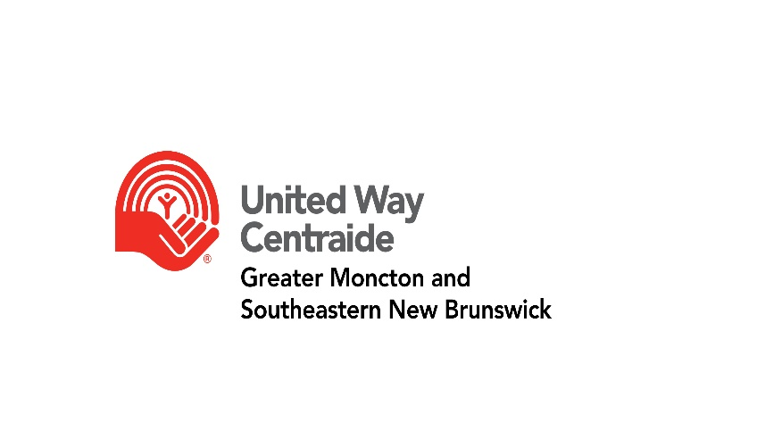

Stairclimb Pledge Form

Team Name: _______________________________________________________________
Team Member Name: ______________________________
Team Registration: $100
Team Pledge Request: $500
Please contact Melissa at events@moncton.unitedway.ca to register.
Receipts will automatically be generated for donations of $20 or more. We will need a mailing address for a tax receipt.
Name | Email | Phone # | Donation Amount | Tax Receipt  Y/N | Mailing Address
 |  |  |  | TOTAL:
Please note: United Way of Greater Moncton & SENB is committed to protecting your privacy. Your information will only be used to help us in our Campaign, and to properly administer, acknowledge and recognize your donation and fulfill your information requests.

*****************************************************************************************
Please read carefully. Waivers must be signed prior to the event.
I understand that the activity I am undertaking is physically demanding. In consideration United Way of Greater Moncton & SENB, I, the undersigned, hereby for myself, individually and for my heirs, my executors and administrators contractually waive and relinquish any rights and claims and damages I may have against United Way of Greater Moncton & SENB, the volunteers, all sponsors of this event, their representatives, successors and assigns for any and all injuries, loss or damage to me or my property suffered during this event. I hereby grant full permission to United Way of Greater Moncton & SENB and/or agents authorized by them to use any photographs, video recordings or any other record of this event for any legitimate purposes.
Release Form Participant’s Name: ________________________________________________
Participant’s age (if under 18): ____________________________________
Date: _______________________________________
Signature of participant/parent/guardian: ______________________________________________
**Parent or guardian name and signature required if participant is under the age of 18.

